Resources – Outside of Lincoln and Omaha

Generally:
- www.findhelp.org or call 211

If Currently Homeless:
- If you are currently experiencing homelessness, start by contacting a public access point for the All Doors Lead Home Coordinated Entry program. This program will prioritize connecting those experiencing homelessness to needed resources. All public access points to apply for this prioritization program are found here: https://community-services.unl.edu/coordinated-entry-public-access-points-balance-state/

Hall County Resources
- Hope Harbor – shelter (women and children) and resource navigation (coordinated entry public access point) (308) 385-5190
  - https://www.hopeharborgi.org/
- Crossroads Mission Avenue – shelter (men) 308-675-1973
  - https://www.crossroadsmission.com/
- Central Nebraska Community Action Partnership – rental assistance and resource navigation (308) 745-0780
  - Home : Central Nebraska Community Action Partnership
- Catholic Social Services of Southern Nebraska – rental and utility assistance 402.463.2112
  - https://csshope.org/what_we_do/programs/family_support.html
- Independence Rising - help with housing case management for elderly/people with disabilities (308) 382-9255
  - https://irnebraska.org/contact/
- Central District Health Department – rental assistance and resources 308.385.5175
  - https://www.cdhd.ne.gov/

Low-Income Housing in Hall County
- Public Housing - Hall County Housing Authority 308-385-5530
  - Review properties: https://www.hcha.net/our_properties/index.php
  - Apply for public housing or housing choice voucher: https://webgen1.revize.com/revize/hallcntyhousingauthorityne/resources/applications.php
- NOTE: when calling properties, especially LIHTC properties, keep in mind they may also have market rate units. Ask whether there is a subsidized or affordable unit available when you call.
- French Village (subsidized housing) (308) 384-8329, (402) 861-6616
  - 936 S Clark St, Grand Island, NE 68801
- Fonner Villa (subsidized housing) 308-384-7896
  - 1137 S Pine St Grand Island NE 68801
- Central Nebraska Goodwill Housing (subsidized housing) 308-384-7896
  - 1909 S Lincoln Ave Grand Island NE 68801
- Riverbend Apts Phase I (LIHTC) 308-398-0678
  - 102 Lakeview Circle, Grand Island NE 68803
- Victory Place (LIHTC: Assistance available to income-eligible applicants) (Veterans get priority) 308-910-0016
  - 2325 North Broadwell, Grand Island, NE 68803
  - https://www.knudsonmanagement.com/victory-placeveterans-housing
- Silverwood Apts (LIHTC) (has 4-bedroom units) 402-434-3344
  - 716 W Stolley Park Rd. Grand Island NE 68801
- Stonewood Townhomes I and II (LIHTC) 308-946-3826
  - 1128 Stonewood Ave, Grand Island NE 68803
- Ridgewood Crown (LIHTC)
  - 711 Ridgewood Ave, Grand Island NE 68803
- Westridge Crown (LIHTC)
  - 828 Ridgewood Ave, Grand Island NE 68803
- Winridge Townhomes I and II (LIHTC)
  - 945 Winridge Ave Grand Island NE 68803
- Walnut Housing (LIHTC)
  - 504 N Elm St, Grand Island NE 68801
- Cherry Park Apts. Phase II (LIHTC)
  - 415 S Cherry St Grand Island NE 68801
- Holiday Garden Townhomes II, 913-671-3300
  - 2004 N Wheeler Ave, Grand Island NE 68801
- Southlawn/Woodland Apartment Homes (55+) (402) 434-3344.
  - https://exceldg.com/properties/southlawn-iv-apartments/
- Platte Valley Apartments (subsidized housing for people with disabilities) (308) 224-7686
  - https://www.seldin.com/plattevalley
- Residences at Liberty Campus (subsidized housing for 55+ and veterans) 308-395-7073
  - https://www.libertycampusresidences.com/
- Grand Island Senior Homes (subsidized housing for 62+ and those with disabilities) 308.381.7227
  - https://chrysalislutheranhomes.com/
- Colonial Square (subsidized housing & LIHTC) 308-384-7874
  - 508 E 16th St, Grand Island NE 68801
  - 515 E 16th St, Grand Island NE 68801
- Grandview – affordable independent senior living (55+) (308) 382-6163
  - https://www.seldin.com/grandview

Buffalo County
- See pamphlet.

Rest of Nebraska
- https://resources.hud.gov/# HUD Resource Locator, look for local housing authorities or subsidized housing
- Community Action Partnerships (rent help and sometimes affordable housing)
  - Northeast Nebraska Community Action Partnership, https://nencap.org/services/
  - Southeast Nebraska Community Action Partnership, https://www.senca.org/
  - Mid-Nebraska Community Action Partnership, https://communityactionmidne.com/
  - Central Nebraska Community Action Partnership, https://centralnebraskacap.com/
  - Blue Valley Community Action Partnership, https://www.bvca.net/
  - Community Action Partnership of Western Nebraska, https://capwn.org/supportive-health/#housing
- Crossroads Mission – shelter (men) (Hastings, GI, Kearney, Lexington)
  - https://www.crossroadsmission.com/
- Catholic Social Services of Southern Nebraska (rent and utility help)
  - 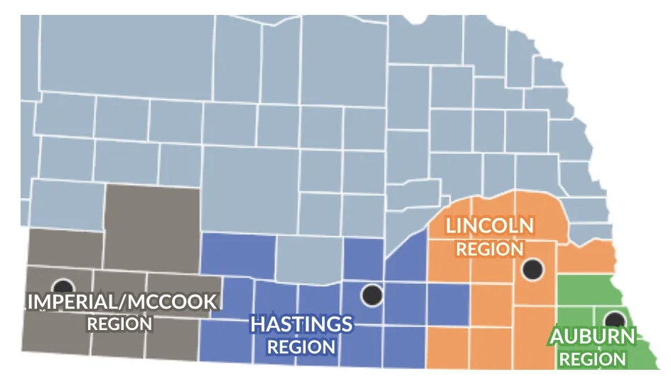
  - https://csshope.org/what_we_do/programs/family_support.html
- Region 1 – HART Program (Housing assistance and community support for those who meet program requirements for mental illness or substance abuse) 308-635-3173
  - https://www.region1bhs.net/vnews/display.v/SEC/Services%7CHART%20Program
- Offices on Aging (household and other services)
  - Eastern Nebraska Office on Aging (offices statewide, misc social resources including housekeeping), https://enoa.org/
  - Blue Rivers Area Agency on Aging (Gage, Jefferson, Johnson, Nemaha, Otoe, Pawnee, Richardson, and Thayer Counties) https://www.braaa.org/
- Scottsbluff: Cirrus House (resource navigation and affordable housing) (308) 635-1488
  - https://cirrushouse.org/contact
- Find Help Norfolk
  - https://nfc.findhelp.com/
- Independence Rising (help with housing for elderly/disabilities)
  - https://irnebraska.org/contact/
- Grand Island: (308) 382-9255
- Scottsbluff: (308) 633-7025
- North Platte: 308-382-9255
- Gothenburg: (308) 537-4332
- Kearny: (308) 708-2392
- Chadron: (308) 432-6857

